AATC_Weather
This module is used to account for changes in weather and calculates the effect on the estimated speed of the drone and therefore the estimation of the arrival time. The program uses the open weather map service and obtains the forecast for a specific location. This service requires an API key which is stored in the AATC_Config module. Depending on the price tier chosen the number of allowed requests change change, if more requests are needed one will have to move to a higher tier.

The pyowm module is used to access the OWM API. AATC_Coordinate is required for some coordinate transformations as well as the coordinate objects. The math module is required for the trigonometric functions. Time is used to get the forecast for the correct time. The AATC_Config module is used to store the API key.

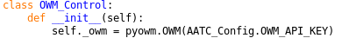
The OWM_Control class is used to manage the OWM interface object as well as provide methods related to the OWM system. The owm interface is created using the API key stored in AATC_Config.

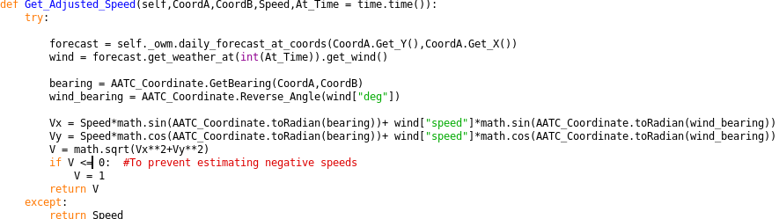
The Get Adjusted speed method is used to calculate the estimated speed of the drone under the effect of the wind. The function takes two coordinate objects as well as an integer At_Time variable and the drone speed. The Coordinates are used to obtain the weather forecast and calculate the bearing while the At_Time variable controls the time at which the speed estimate will take place.
First the forecast object is obtained using the OWM system at the coordinate defined by CoordA. The wind is then obtained at the time in the At_Time variable and stored in the wind variable. The bearing between the two coordinates and the wind bearing are calculated. The velocities in the X/Y axis are calculated by adding the velocities and the magnitude of the velocity is calculated. If the velocity is less than or equal to zero the velocity is set to 1, preventing zero division errors or negative speeds. Should an exception occur e.g. the service is down then it will be caught by the try/except brackets and the original speed is returned.

